Bug Report

Ariel Dotan

**Title**: Give permission within the App

**Description**: Upon selecting "Not Allow" on the phone's location prompt and granting permission within the app, cause an issue where the app loads indefinitely without displaying errors, failing to direct the user to the app's home page.

**Steps**:

1. Open Travel maker app
2. Click “Not Allow” on phone prompt
3. Click on “Give Permission” within the app

**Expected Result:**

Upon selecting "Not Allow" on the phone's location prompt and granting permission within the app, the app is intended to seamlessly direct the user to the home page.

**Actual Result:**

Selecting "Not Allow" on the location prompt, then granting permission in the app, leads to an indefinite loading issue. Users are unable to reach the home page, and no error messages are displayed. The app continues loading without interruption, providing no indication of the problem.

Severity: Critical

**See Attachments:**

****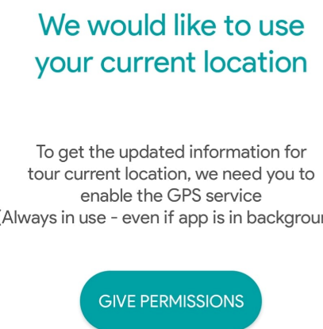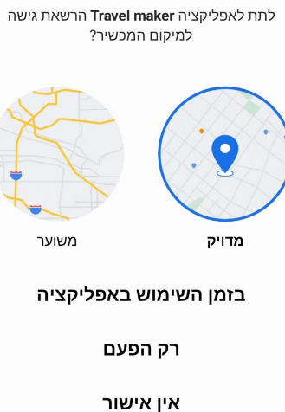

**Title**: Press for more info not clickable

**Description**: "Press for more Info" may be misleading if users are not meant to click the button. This confuses the user who is supposed to refrain from clicking to view the weather forecast for the upcoming days.

**Steps**:

**1**. Navigate to “Weather” page

2. Click on different date in “press for more details”

3. Click on a different date underneath the "Press for More Details" section.

**Expected Result:**

**“**Press for more info” should be clickable and allow the user to see the weather forecast for the upcoming days

**Actual Result:**

“Press for more info” not opens more weather info when clicking.

Severity: Low

**See Attachments:**

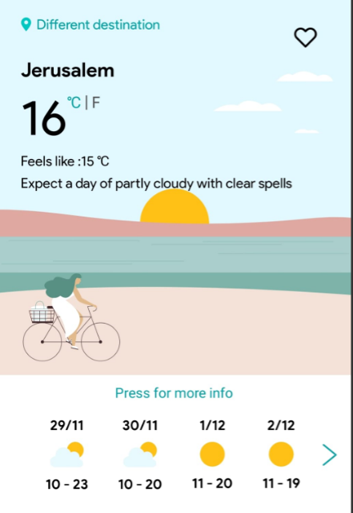

**Title:** No Exit Button appear in weather pop up

**Description**: When opening the weather pop-up and attempting to close the window, there is no visible indication of a button to dismiss the window. As a result, users are uncertain how to close the window.

**Steps**:

**1**.Navigate to “Weather” page

**2.** Click on a different date underneath the "Press for More Details" section

**Expected Result:**

The weather pop-up should have a clear and intuitive exit button to signify its purpose

**Actual Result:**

The weather pop-up didn’t have a clear and intuitive exit button to signify its purpose

Severity: Medium

**See Attachments:**

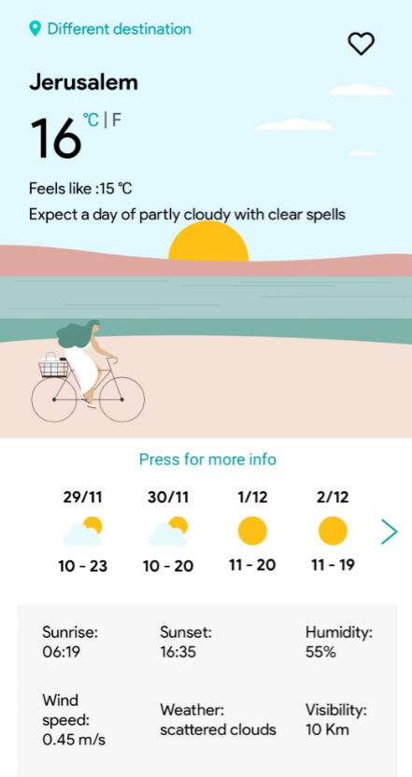

**Title:** Crashing in “Search A place” without Input

**Description:** When the user attempts to proceed by clicking 'Search Weather' without entering an area name the App is Crashing immediately

**Steps:**

**1.** Navigate to Maps page

**2.** Leave “search a place” empty

**3.** Click “Search Weather”

**Expected Result:**

When the user attempts to proceed by clicking 'Search Weather' without entering an area name, a pop-up will appear with the message 'Please fill in the area name.' The system will prevent the user from advancing to the next step until a valid area name is provided.

**Actual Result:**

When the user attempts to proceed by clicking 'Search Weather' without entering an area name. the app is crashing

Severity: Medium

Error log: kotlin.UninitializedPropertyAccessException: lateinit property mAddress has not been initialized

The error occurs when an attempt is made to access a variable defined with `lateinit` and it has not yet been set to its value before its use.

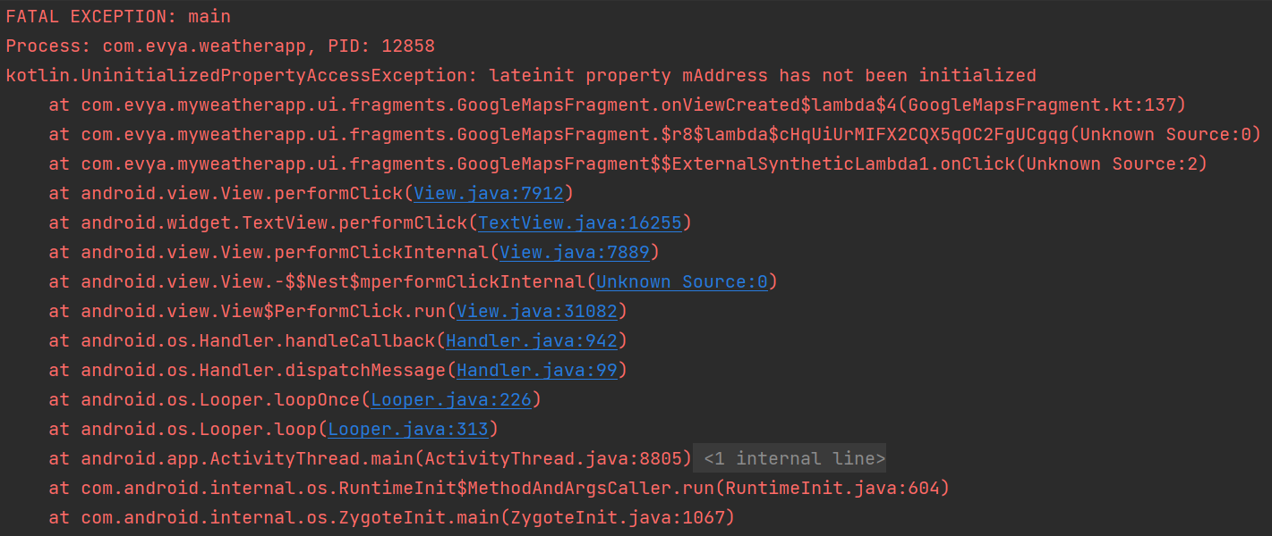 

**Title:** No message indicates lost internet connection

**Description:** When the user trying to open the app without internet connection

The app running without indicating a message saying “Please connect to internet”

**Steps:**

1. Navigate to phone toolbar
2. Turn of wifi and mobile data
3. Launch Travel maker app

**Expected Result:**

When the user trying to open the app without internet connection. A pop up will appear “please connect to internet” and the system will not allow the user to continue

**Actual Result:**

When opening the app without an internet connection, it allows proceeding to the home page instead of displaying an expected error message

Severity: Low

Error log: kotlin.UninitializedPropertyAccessException: lateinit property mAddress has not been initialized

The error occurs when an attempt is made to access a variable defined with `lateinit` and it has not yet been set to its value before its use.

**See attachments:**

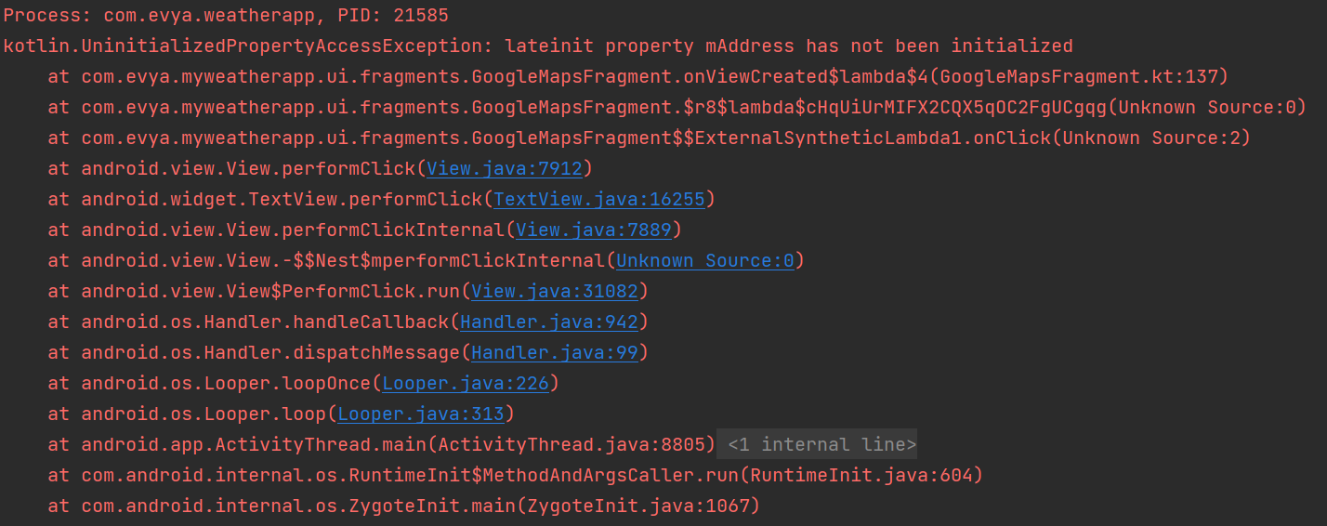

**Title:** Turn off phone location settings

**Description:** When the user turns off the phone's location services within the application, the app initiates without signaling that the location feature has been deactivated. This absence of notification could result in user confusion, as there is no clear information regarding the status of location services. Such ambiguity may impact the app's functionality, especially features that depend on precise location data.

**Steps:**

1. Launch Travel maker
2. Navigate to phone location settings
3. Turn off location within the phone
4. Return to Travel maker
5. Click on “show weather”

**Expected Result:**

As soon as the user turn off the location in phone. A message will pop up “please enable location in phone settings” and the system will not let user to continue using the app

**Actual Result:**

When the user turns off the location on the phone and attempts to use the app, it crashes without displaying any error message.

**Title:** Error pop up appears in different location

**Description:** Clicking on the search bar and tapping outside the screen triggers an error pop-up to appear in the same location. However, if the user subsequently taps outside of the screen, a different pop-up appears in an unexpected location. This inconsistency in pop-up behavior may lead to user confusion and impact the overall usability of the application.

**Steps:**

1. Navigate to Maps page
2. Click on “Search a place”
3. Leave the field empty
4. Tap outside of the screen

**Expected Result:**

When clicking on the search bar and subsequently tapping outside of the screen An Error pop-up will appear in same location

**Actual Result:**

When clicking on the search bar and subsequently tapping outside of the screen A pop-up appears in different location

Severity: Low

**See attachments:**

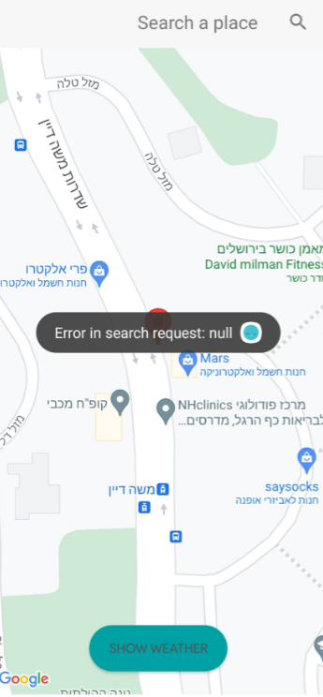 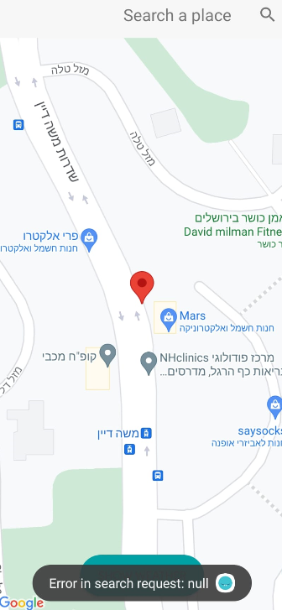

**Title:** Navigation mark leads to crash in open space area

**Description:** When a user attempts to mark a location in an open space and clicks "Show Weather," the system prompts an alert indicating that the location is unknown. However, the intended functionality is not achieved, and instead, the system experiences a software crash. This issue hinders the user's ability to set a navigation marker and obtain weather information as intended

**Steps:**

1. Navigate to maps page
2. Set navigation mark on open space
3. Click “show weather”

**Expected Result:**

When a user will mark a location in an open space and clicks "Show Weather," the system will prompt an alert indicating that the location is unknown.

**Actual Result:**

when a user attempts to set a navigation marker in an open space and clicks "Show Weather," the system does not function as intended, leading to a software crash.

Severity: Medium

Error log: kotlin.UninitializedPropertyAccessException: lateinit property mAddress has not been initialized

The error occurs when an attempt is made to access a variable defined with `lateinit` and it has not yet been set to its value before its use.

**See attachments:**

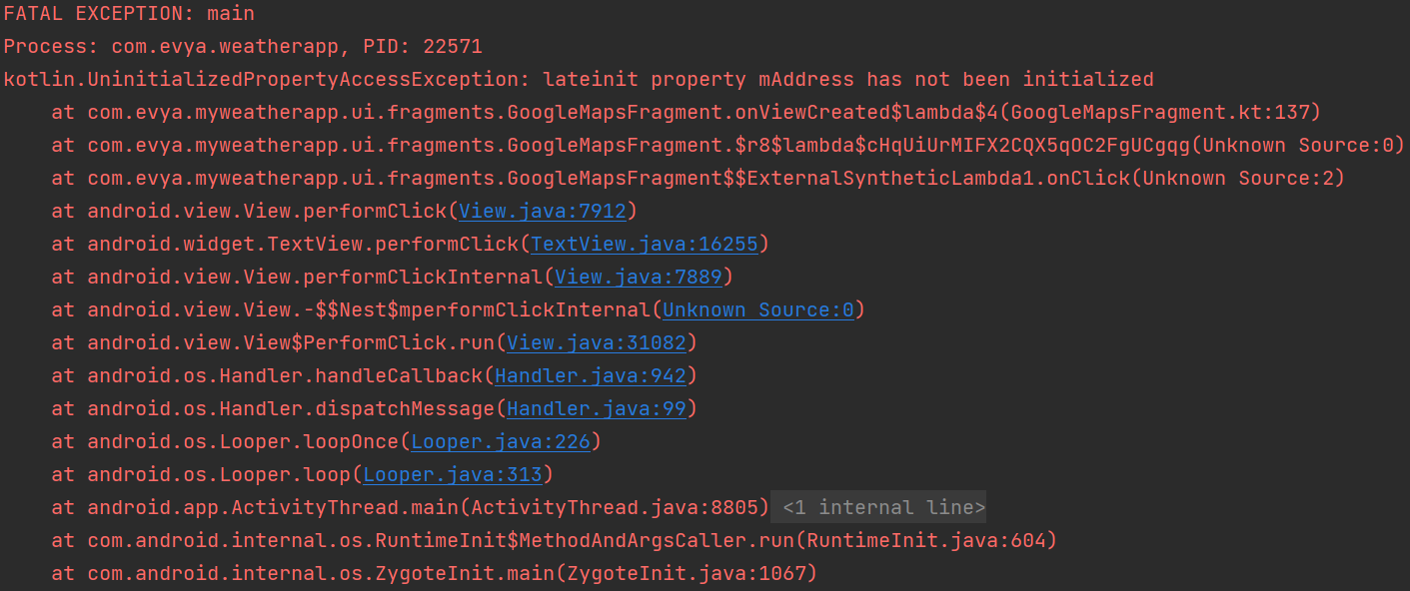

**Title:** Location Address invisible

**Description**: When a user designates a recognized address and activates the "Show Weather" button, the expected behavior is for the system to display the corresponding weather information for that location. However, an issue arises as the application fails to respond appropriately, resulting in a system crash upon attempting to click the "Show Weather" button. This malfunction hampers the user's ability to access weather details for the designated address, impacting the intended functionality of the app.

**Steps:**

1. Navigate to maps page
2. Mark known location (מקדש יעקוב )
3. Click on show weather

**Expected Result:**

When the user marks a known address and clicks on the "show weather" button, the system will display the address of that area included weather

**Actual Result:**

The application does not respond properly and crashes when you try to press the "show weather" button

Severity: Critical

Error log: kotlin.UninitializedPropertyAccessException: lateinit property mAddress has not been initialized

**See attachments:**



**Title:** Element’s appearance doesn’t change in dark mode

**Description**: When the user activates a dark mode on the phone, elements of the application should be compatible with the same mode defined in the dark color In practice, the color of the elements does not change and is hidden visually

**Steps:**

1. Navigate to phone settings
2. Click on Display
3. Turn on “dark mode”
4. Launch Travel maker app
5. Navigate to attractions page

**Expected Result:**

When a phone has been set to dark mode, all page elements will match that dark mode without tearing or missing elements

**Actual Result:**

Dark mode on the phone hides the elements of the page and don’t change colors to black

Severity: Medium

Error log: None

**See attachments:**

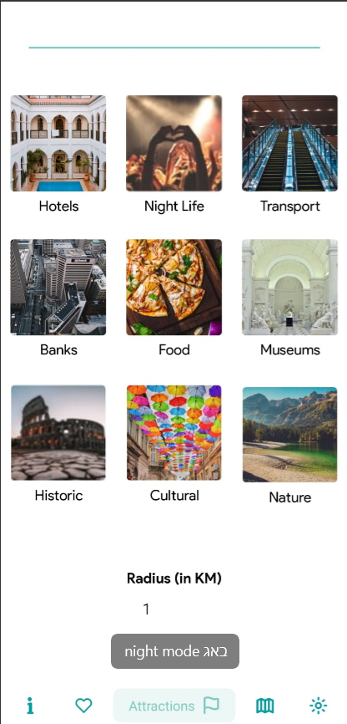

**Title:** Search bar invisible in dark mode

**Description:** When User turn on “Dark mode” within the phone

The search bar should be visible in dark mode clearly

**Steps:**

1. Navigate to phone settings
2. Click on Display
3. Turn on “dark mode”
4. Launch Travel maker app
5. Navigate to attractions page

**Expected Result:**

Search bar should be visible after user turn on dark mode phone

**Actual Result:**

Search bar is invisible after turning on dark mode

Severity: Medium

Error log: None

**See attachments:**



**Title:** Radius invisible in dark mode

**Description:** after the user enables dark mode within the phone

Radius should be matches with dark mode appearance without errors

But when the user enables dark mode the radius feature is half invisible

**Steps:**

1. Navigate to phone settings
2. Click on Display
3. Turn on “dark mode”
4. Launch Travel maker app
5. Navigate to attractions page

**Expected Result:**

Radius should be visible after user turn on dark mode

**Actual Result:**

Radius is not visible after turning on dark mode

Severity: low

Error log: None

**See attachments:**

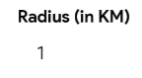

**Title:** Rotate app is not available

**Description:** The application should seamlessly adjust to landscape mode, and all interface elements should reposition themselves intuitively when the user enable in phone rotation. However, there is an issue where the app and its elements fail to rotate to landscape mode as intended.

**Steps:**

1. Navigate to Display settings within phone
2. Click on Advanced
3. Toggle on “Auto Rotate screen”
4. Launch Travel maker app
5. Rotate the phone horizontally.

**Expected Result:**

The application should seamlessly adjust to landscape mode, and all interface elements should reposition themselves intuitively.

**Actual Result:**

The application fails to properly adjust to landscape mode, and the interface elements do not reposition correctly, resulting in a non-user-friendly experience.

Error logs: None

**Title:** Search activities not responsive

**Description:** The primary function of the Search activities is to enable users to search for custom activities by entering an area name. Ideally, upon typing the area name, the search activities should seamlessly guide the user to the maps and showcase the desired activity. Unfortunately, the current functionality falls short of expectations, resulting in unexpected crashes and a lack of search results. This issue impedes the smooth operation of the search activities, hindering users from accessing the intended information effectively.

**Steps:**

1. Navigate to attractions page
2. Click on “Search Activities”
3. Type “bars”
4. Click the name from the list

**Expected Result:**

“Search Activities” allow to type “bars” and should lead to bars area without errors

**Actual Result:**

When user type “Bars” then click Enter the app is crashing

Severity: Critical

Error log: None

**Title:** Search activities not directs user to maps

**Description:** The primary function of the Search activities is to enable users to search for custom activities by entering an area name. Ideally, upon typing the area name, the search activities should seamlessly guide the user to the maps and showcase the desired activity. Unfortunately, the current functionality falls short of expectations, resulting in unexpected crashes and a lack of search results. This issue impedes the smooth operation of the search activities, hindering users from accessing the intended information effectively.

**Steps:**

1. Navigate to attractions page
2. Click on “Search Activities”
3. Type “art galleries”
4. Click the name from the list

**Expected Result:**

“Search Activities” allow to type “Art Galleries” and should lead to art galleries area without errors

**Actual Result:**

Typing “art galleries” didn’t lead to art galleries area

Error log: None

Severity:

**Title:** Search Activities not display entered contact clearly

**Description**: When users input text in the "Search Activities" field, the text should be displayed clearly without any tearing. Unfortunately, the current behavior exhibits tearing, causing the text to be incomplete and not fully visible. This results in a suboptimal user experience, as users are unable to see the full letters, impacting the usability of the feature.

**Steps:**

1. Navigate to attractions page
2. Click on “Search Activities”
3. Type “bars”
4. Click the name from the list

**Expected Result:**

Activities search field will display the entered content “Bars” clearly and smoothly without tearing

**Actual Result:**

The "Activities Search" field exhibits a display issue where the entered content, in this instance "Bars," appears with tearing and lacks clarity.

Severity: Medium

Error log: None

**See attachments:**

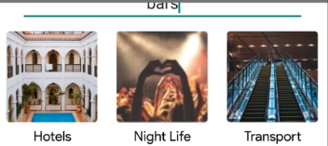

**Title:** Search Activities list not display

**Description:** Clicking the "Search Activities" bar is intended to display a list of locations clearly without tearing. However, when clicking "Search Activities," the expected list of locations fails to appear, and the field exhibits tearing, preventing the full display of content. This discrepancy in functionality results in an undesirable user experience, as users are unable to view the list of locations properly.

**Steps:**

1. Navigate to attractions page
2. Click on “Search Activities”

**Expected Result:**

When clicking “search activities bar” a list of location will be seen clearly without tearing

**Actual Result:**

Clicking “search activities” not showing a list of location

Severity: low

Error log: None

**Title:** Missing Logs in “Search Activities”

**Description:** When performing search operations or clicking on a result, a log should appear in the GET methodology however no logs are appeared thus preventing the testability of the feature

**Steps:**

1. Navigate to attractions page
2. Click on “Search Activities”
3. Type “Bars”
4. Click “bars” from the list

**Expected Result:**

When performing search operations or clicking on a result, a log should appear in the GET methodology

**Actual Result:**

No logs are appearing

Severity: High

Error log: None

**Title:** Favorites page doesn’t allow to add multiple areas

**Description:** While the Favorites page is designed to enable users to add multiple favorite areas without encountering errors or limitations, the current functionality presents a discrepancy. In practice, only one area can be added, and there is no notification provided when the previous area is deleted or when a restriction is encountered. This inconsistency in the expected behavior impacts the user's ability to effectively manage and add favorite areas, leading to a potential source of confusion and frustration.

**Steps:**

1. Navigate to maps Page
2. Click on “Search Area”
3. Type “Holon”
4. Click “Show Weather”
5. Click on “heart” to add the location to favorites
6. Navigate to “favorites” page
7. Verify “Holon” is added
8. Navigate back to maps
9. Click on “Search Area”
10. Type “Ranana”
11. Click “Show Weather”
12. Click on “heart” to add the location to favorites

**Expected Result:**

The favorites page should allow you to add multiple favorite areas without error

**Actual Result:**

Favorites page allows only 1 area

Severity: Low

Error log: None

**See attachments:**

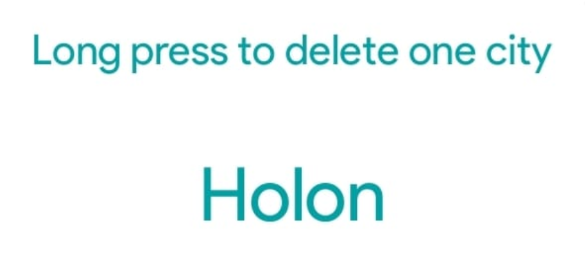 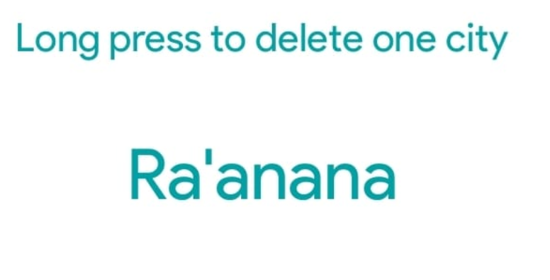

**Title:** Trash icon available when there is no favorite area saved

**Description:** The Trash feature is intended to permit users to remove favorite areas without encountering errors. Nonetheless, an issue arises as the Trash feature remains available even when no favorite areas have been saved. This inconsistency in functionality may cause confusion for users, as the Trash feature should only be accessible when there are existing favorite areas to remove.

**Steps:**

1. Navigate to “Favorites” page
2. Verify page is empty
3. Click on “trash”

**Expected Result:**

Trash icon will not be clickable when there isn’t favorites area

**Actual Result:**

Trash Button is clickable when there isn’t favorites area

Severity: Low

Error log: None

**See Attachments:**

 